Internal Quarterly Report

Date of Report: 3st Quarterly Report, July 1, 2023
Contract Number: 693JK32210009POTA
Prepared for: Government Agency: DOT and Co-funders
Project Title: Innovative Leak Detection Methods for Gas and Liquid Pipelines
Prepared by: Pipeline Research Council International, Inc.
Contact Information: Gary Choquette: gchoquette@prci.org phone: 402-915-5565
For quarterly period ending: June 30, 2023

1: Items Completed During this Quarterly Period:

Item # | Task # | Activity/Deliverable | Title | Federal Cost | Cost Share
3 | 5 | Development of simulated systems with measurement errors and simulated leaks | Results to be included in quarterly report | $10,220 | $5,110
4 | 3 | Host site review checklist development | Results to be included in quarterly report | $8,426 | $4,213
5 | 1 | Literature review and compendium update | Literature review compendium | $10,248 | $5,124
8 | 1 | Quarterly project management & status update | Submit 2nd quarterly report | $4,866 | $2,433

Item # | Task # | Activity/Deliverable | Title | Federal Cost | Cost Share
6 | 2 | Inline flow measurement selection guidelines | Results submitted with this quarterly report. The report is more comprehensive than originally planned. Extra effort was absorbed by PRCI. | $80,704 | $40,352
11 | 1 | Quarterly project management & status update | Submit 3nd quarterly report | $4,866 | $2,433

2: Items Not Completed During this Quarterly Period:

Item # | Task # | Activity/Deliverable | Title | Federal Cost | Cost Share
7 | 4 | PODS draft SCADA interface data model | Results to be included in quarterly report | $23,796 | $23,796
9 | 3 | Host site review | Summary of the review and issues to be included in quarterly report | $9,984 | $4,992

3: Project Financial Tracking During this Quarterly Period:

Note that this chart reflects Federal share only.

4: Project Technical Status
Activities and completion percentage is summarized in the following table:

Item No. | Task No. | Activity/Deliverable | Quarter Code | % | Note | Work Accum
1 | 1 | Project kick off meeting and scope review | 2022Q4 | 100% | Completed | $7,960
2 | 1 | Quarterly project management & status update | 2022Q4 | 100% | Completed | $1,444
3 | 5 | Development of simulated systems with measurement errors and simulated leaks | 2023Q1 | 100% | Completed | $10,220
4 | 3 | Host site review checklist development | 2023Q1 | 100% | Completed | $8,426
5 | 1 | Literature review and compendium update | 2023Q1 | 100% | Underway | $10,248
6 | 2 | Inline flow measurement selection guidelines | 2023Q1 | 100% | The report is more comprehensive than originally planned. No additional costs will be charged to the project. | $80,704
7 | 4 | PODS draft SCADA interface data model | 2023Q1 | 10% | Work was started but has been halted as the model should be built upon lessons learned from receiving and processing the operator data. This is not expected to alter the planned completion date of the project. | $4,759
8 | 1 | Quarterly project management & status update | 2023Q1 | 100% | Completed | $4,866
9 | 3 | Host site review | 2023Q2 | 25% | Initial data analytics completed. Issues were communicated back to the host site. | $9,984
10 | 2 | Validation of overlapping zone balancing and statistical flow calibration on simulated systems | 2023Q2 | 50% | Additional analysis is required on second set of data and a corresponding assessment of the capabilities of the methods on the simulated system. | $12,348
11 | 1 | Quarterly project management & status update | 2023Q2 | 100% | Completed | $24,866
9 | 6 | Flow pattern matching and data bin method analysis | 2023Q3 | 20% |  | $7,987
11 | 1 | Quarterly project management & status update | 2023Q3 | 0% |  | $0
12 | 3 | Host site data model cleanup | 2023Q4 | 15% |  | $4,506
13 | 5 | Quasi transient pack sensitivity analysis | 2023Q4 | 0% |  | $0
15 | 1 | Quarterly project management & status update | 2023Q4 | 0% |  | $0
16 | 2 | Overlapping zone description and documentation | 2024Q1 | 0% |  | $0
17 | 7 | Simplified equations of state and CHDP estimation | 2024Q1 | 0% |  | $0
18 | 2 | Host site implementation of overlapping zone balancing | 2024Q1 | 0% |  | $0
19 | 1 | Quarterly project management & status update | 2024Q1 | 0% |  | $0
20 | 1 | Quarterly project management & status update | 2024Q2 | 0% |  | $0
21 | 5 | Quasi transient pack method documentation | 2024Q3 | 0% |  | $0
22 | 1 | Quarterly project management & status update | 2024Q3 | 0% |  | $0
23 | 3 | Host site data gathering | 2024Q4 | 0% |  | $0
24 | 2 | Pipeline simulated leak analytics w/ tuned and 'as found' system | 2024Q4 | 0% |  | $0
25 | 1 | Quarterly project management & status update | 2024Q4 | 0% |  | $0
26 | 3 | Host site data monitoring and analytics | 2025Q1 | 0% |  | $0
27 | 1 | Quarterly project management & status update | 2025Q1 | 0% |  | $0
28 | 1 | Draft final report | 2025Q2 | 0% |  | $0
29 | 1 | Quarterly project management & status update | 2025Q2 | 0% |  | $0
30 | 1 | Quarterly project management & status update | 2025Q3 | 0% |  | $0
31 | 1 | Final report and presentation | 2025Q3 | 0% |  | $0
 |  |  |  |  |  | $188,318

Additional information on tasks actively underway or completed this period:

- Item 3 (MS2-5): Development of a simulated system has been completed. Analysis has been completed on the first 25 points of the simulated system. Feedback has been supplied to the developer of the data and the next 75 points will be produced.

Using the following zones in the simulated system:
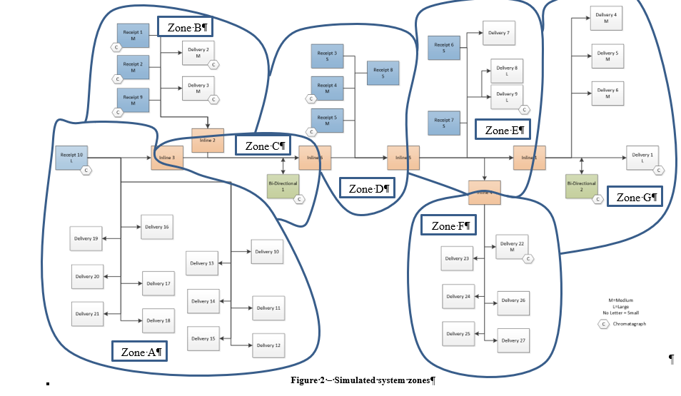
Figure 1 - Simulated system zones

A more direct solution to the overlapping zone balance was identified using the simulated system. The simplest process to calibrate is to take a set of data that is known to be reliable and excludes abnormal events such as pipeline blowdown/purge. It also assumes that the system is generally well behaved in that the measurement uncertainty is approximately randomly distributed across all meters with some meters measuring high and others low. The process to perform calibration of all inline meters within a system involves:

- For a specified flow period (e.g., hour, day, month, etc.) sum the apparent receipt and sum the apparent delivery flows.
- Average the receipt and delivery sums.
- Normalize the receipt point values such that they sum to the average of the system receipt and delivery flows.
- Normalize the delivery point volumes.
- Calculate the flow through the inline meters required produce LAUF for each zone to zero. This will produce the corrected flows for the inline meters.
- Repeat calculations for additional flow periods with variability in flow rates.
- Perform a regression using the apparent flows and corrected flows for the inline meters.
A sample (subset) of the adjustments made for the simulated system can be found in Table 1. Note that the receipt and delivery adjustments should be close to the value of 1.0. If they are significantly different than 1, the dataset should be evaluated for gross errors.

Table 1 – System/Zone adjustments for inline meter calibration
Meters | Avg Receipt Delivery | Receipt Adjustment | Delivery Adjustment | A Receipt Adjusted | A Delivery Adjusted
Set 1 | 23.259 | 1.000 | 1.000 | 13.255 | 1.037
Set 2 | 24.621 | 1.001 | 0.999 | 15.204 | 1.010
Set 3 | 21.861 | 1.001 | 0.999 | 12.840 | 1.030
Set 4 | 22.748 | 1.001 | 0.999 | 12.699 | 0.977
Set 5 | 24.557 | 1.000 | 1.000 | 15.473 | 1.065
Set 6 | 24.034 | 1.001 | 0.999 | 14.572 | 0.940
Set 7 | 19.946 | 1.001 | 0.999 | 11.902 | 0.919
Set 8 | 20.130 | 1.001 | 0.999 | 12.446 | 0.963
Set 9 | 21.230 | 1.000 | 1.000 | 12.839 | 0.884

The corrected inline flows were then fit using a linear regression as shown in Table 2. Note that the root mean square (RMS) values for all of these meters are close to the ideal value of 1.0.
Table 2 – Calculated linear correction coefficients for simulated system inline flow meters
Type | Inline 1 | Inline 2 | Inline 3 | Inline 4 | Inline 5 | Inline 6
Slope | 0.98378 | 0.99736 | 1.02462 | 1.01766 | 0.99679 | 0.99102
Intercept | -0.01476 | -0.00273 | -0.05387 | -0.00042 | -0.02903 | 0.00480
RMS | 0.99998 | 0.99989 | 0.99993 | 0.99989 | 0.99995 | 0.99994

Using the calibrated values for the inline flow meters (rather than the apparent flows), the zone LAUF values are recalculated. Regressions in LAUF contributions as a function of meter flow percentage of zone flow were performed. Three meters were identified as potential outliers using this method. This forms the first steps of flow pattern matching analytics. Figure 2 shows one measurement point that has a very high correlation to overall LAUF as the flow rate varies indicating that is a potentially high contributor to the impacts on LAUF within that zone.
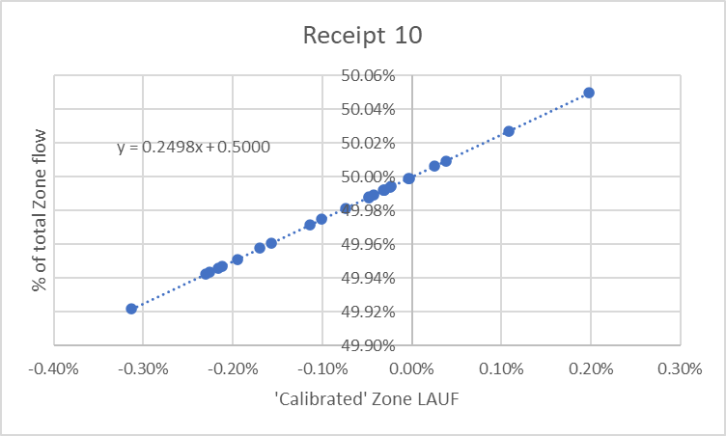
Figure 2 - Zone LAUF sensitivity

- Item 6 (MS2-7): A guidance document to aid in the selection of inline flow measurement for system segmentation purposes has been completed and submitted with this report. This report is intended to be publicly available.

5: Project Schedule –

The project is ahead of schedule on a work completed basis despite having some tasks lag behind. Overall, the project is estimated at 24% complete which is ahead of plan of 16% by end of project Q3.

